Justin Zamecnik

JQ Adams Report

Objectives:

Creating an Active Directory for JQ Adams by creating OUs, permissions, GPOs, and more in order to meet the needs of the project.

Equipment List:

The only equipment used for this lab was a pen and some paper and a laptop to remote desktop to the server and clients.

Notes and Observations:

The lab went smoother than expected. We didn’t have much trouble creating any of the more basic things like the OUs and the GPOs. The issues came when we forgot how to edit permissions and the correct way of sharing folders. Once we got these parts done everything else was straight forward. It mostly consisted of remembering what we had done earlier in the semester.

Diagrams, flowcharts, and figures:

This screeshot shows some of the results form our GPResult command

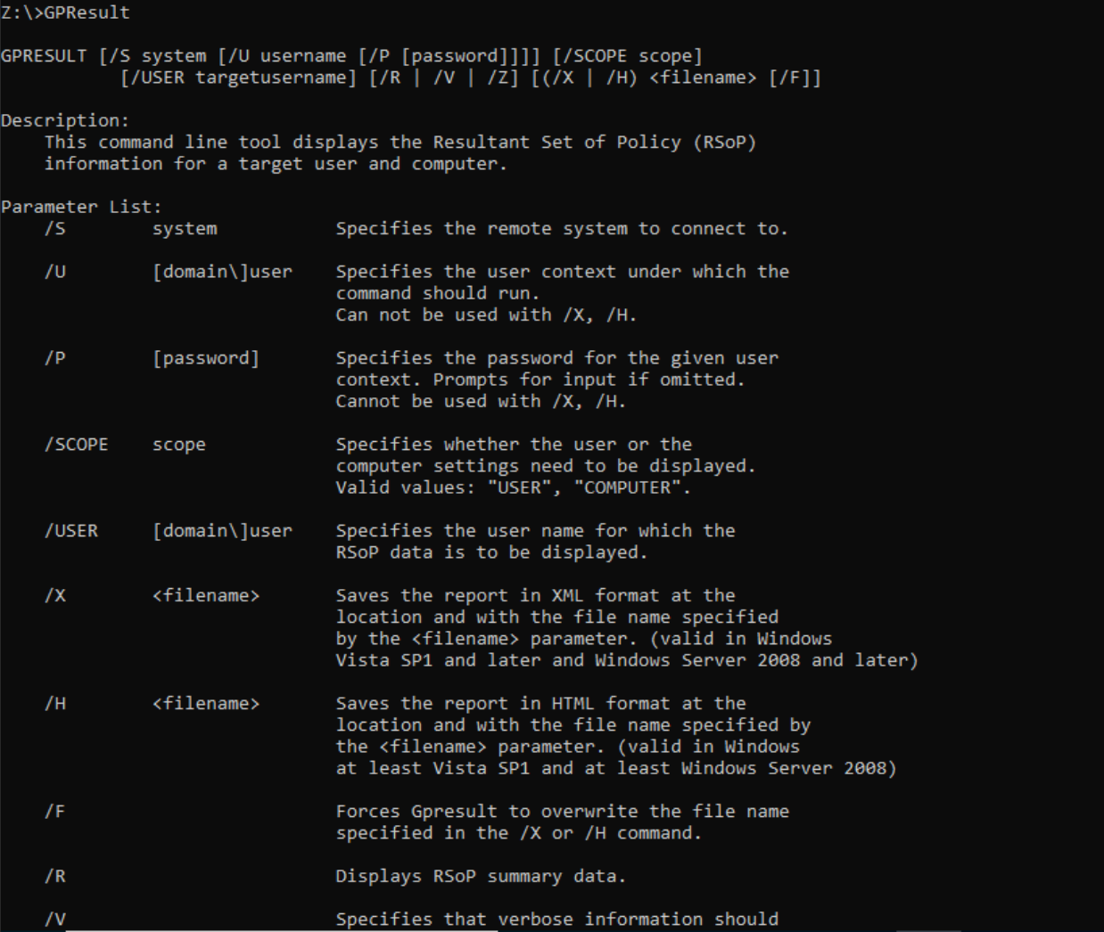

This tree shows the basic setup of the JQ Adams Active Directory.

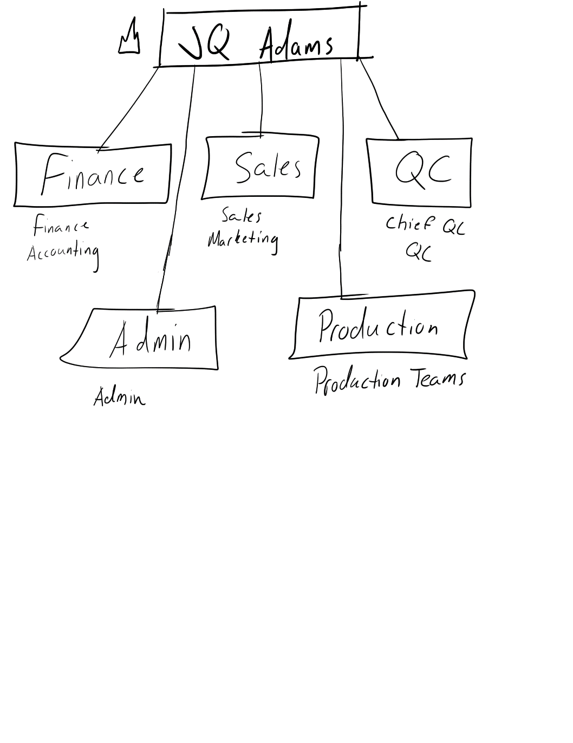

References:

No references were used in this lab.

Questions:

1. What questions would you ask the company to help you plan the Active Directory?

Who are the main users on this Active Directory? Who is the person in charge that I can get information from in order to complete this project? Will anybody be using a laptop at any time? Is the company planning to expand?

1. Describe your Active Directory structure including OUs, users and groups. Include any assumptions you made about the company that affected your design. (You could use something like Visio to display the structure.)

We chose a very basic structure. We realized that many of these groups could be put together. What I mean by that is a lot of the things that Marketing would need would most likely be found in the Sales portion of the Active Directory already. It doesn’t make much sense for us to create two identical large OUs that only differ in name. You can see how we did this for multiple groups when you look at the diagram on page one.

1. Describe your file directory structure you created for the JQ Adams case study. Indicate which folders are being shared.

One of the clear share folders was the Production folder. We had to go into a new server for the Production teams and create a folder that then tracked data and inventory. We then shared these folders with only the production groups because they were the only ones who needed access.

1. What is your naming policy for user accounts?

We kept it simple and used the user’s first name and last initial, for example, mine would be JustinZ. We did this because it would be very easy for the users to remember.

1. Describe how you can delegate full control of managing production user accounts to the Production Vice President.

I would go into the Active Directory Users and Computers tab and then right-click on the Vice President’s name. I could then click Delegate Control, which would then allow me to allow the Vice President to do whatever they wanted within the Active Directory.

1. Describe how you use global groups to group users together and then domain local groups to provide access to network resources. For example, you could describe how you used this concept to provide access for finance users to the AcctSys folder.

We used global groups to group people together in one place. It makes things more organized and easier if we need to go back to them later. We then apply that global group to the domain local group, and then give them the permissions for a particular asset. This process makes things easier because we can edit it easily. Also, if a group consisting of the president and vice president, or something similar to that, need access to another folder somewhere else, then we can simply add their global group into the domain local group instead of adding them individually.

1. Generally speaking, what are the advantages of using global groups to manage users and then using domain local groups on the Security Tab to provide access?

It is easier to create a global group, which can have users from across the whole domain, and then assign that global group to a domain local group, which will narrow down the permissions of the users within the domain. Domain Local groups are much more precise, while Global Groups are pretty simple and are typically used to group users together who will need the same permissions as some of the others.

1. Why is it important to set disk quotas for users?

It limits the storage space that can be used. This should prevent certain users from taking up all of the space.

1. What are at least two advantages of using DFS?

Recovery will be better in case of failure

Increases the security and admin flexibility

1. What group policies did you setup for this project?

We set a group policy called J.Q. Adams

1. What information can you get from the GPresult tool?

It is a command that shows the RSoP for a user or computer based on the GPO settings for that user or computer.

1. Describe how you can use Group Policy to distribute and control Chrome on the client computers.

Well, first you have to download a package for Chrome, that way you can download it and then distribute it throughout the network. Then install Chrome. You then have to make sure that Chrome is assigned. Once this part is done the application should be installed in all domain computer once they restart. This would be what we would’ve done if Chrome decided to cooperate and download for us.

1. Explain how roaming profiles can be useful.

Users can access their data from anywhere in the network.

Conclusion and Reflection:

As you would assume, this was an extremely time-consuming project. It took us awhile to remember how we did a lot of the labs towards the beginning of the semester. We struggled in the beginning, but we managed to remember how simple some of the things are to set up. Basically, we forgot we could simply right click and create the majority of the things we needed for this project. Getting an idea for the domain tree wasn’t too difficult, and within minutes we knew what direction we were heading in. We did struggle with some things like the Production Server and the shared folders within that server. We ran into another issue when we hit the Group Policy portion of the project. Although Group Policy is a recent subject for us in this class, it was tough to remember all of the functions of Group Policy because there is so much that it can do. When we ran into any problem we tried to come together as a group and figure it out, but many times this didn’t work for us. We then had to ask our professor to send us in the right direction in order to get back on track. Our biggest issue during this project was timing. We struggled at times getting together. I know I missed one day, and in the last week we have had a few issues with scheduling now that things are beginning to open back up and we are scheduled to work. Overall, we did a lot better on this project than I think we all anticipated. Although we had some rough patches where we were stuck, we managed to figure things out in the end with some help.